APQB 5.5 Crowding Out

Core Questions
- An increase in government spending financed by borrowing will result in which of the following?
- Private savings will decrease in the short run.
- The real interest rate will decrease in the short run.
- Interest-sensitive private sector spending will increase in the short run.
- Potential real output will increase in the long run.
- The rate of physical capital accumulation will decrease in the long run.
- The table below provides the values, in billions of dollars, of selected macroeconomic variables for a nation at the current real interest rate. The nation is a closed economy with no international transactions. 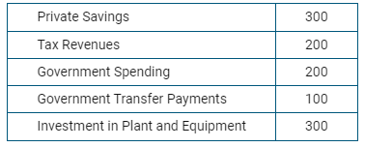
Based on the table above, which of the following is most likely true?
- The government has a budget surplus.
- Consumer spending exceeds disposable income.
- Public savings exceeds private savings.
- National debt is decreasing.
- The government is borrowing.
- The table below provides the values, in billions of dollars, of selected macroeconomic variables for a nation at the current real interest rate. The nation is a closed economy with no international transactions. 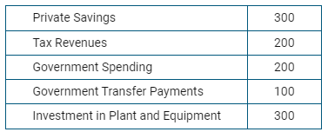
Based on the table above, what will happen to the real interest rate in the loanable funds market and private investment spending in plant and equipment?
- The real interest rate will increase, and private investment spending will increase.
- The real interest rate will increase, and private investment spending will decrease.
- The real interest rate will decrease, and private investment spending will decrease.
- The real interest rate will decrease, and private investment spending will increase.
- The real interest rate will increase, and private investment spending will not change

MC Questions
- Suppose that a national government increased deficit spending on goods and services, increasing its demand for loanable funds In the long run, this policy would most likely result in which of the following changes in this country?
 | Real Interest Rate | Investment
A | Decrease | Decrease
B | Decrease | Increase
C | Increase | Decrease
D | Increase | No Change
E | No change | Increase
- Crowding out is best described as which of the following?
- The decrease in full-employment output caused by an increase in taxes
- The decrease in consumption or private investment spending caused by an increase in government spending
- The decrease in government spending caused by a decrease in taxes
- The increase in the amount of capital outflow caused by the increase in government spending
- The increase in the amount of capital inflow caused by the increase in government spending
- Which of the following effects may result from an expansionary fiscal policy?
- An increase in government savings
- An increase in exports to other countries
- A decrease in the nominal interest rate
- A decrease in aggregate demand
1E 2E 3B 4C 5B 6E 7D 8D 9A 10A 11D

- A decrease in funds available for private business investment
- Crowding out occurs when investment spending by the private sector decreases as a result of
- decreasing interest rates caused by an increase in the supply of government bonds
- decreasing interest rates caused by a decrease in the demand for loanable funds
- decreasing interest rates caused by an increase in government borrowing
- increasing interest rates caused by an increase in government borrowing
- increasing interest rates caused by a decrease in government borrowing
- An increase in government spending financed by increased borrowing will most likely change the real interest rate and the gross private domestic investment in which of the following ways?
 | Real Interest Rate | Gross Private Domestic Investment
A | No change | No change
B | Decrease | Increase
C | Decrease | Decrease
D | Increase | Decrease
E | Increase | Increase
- If investment demand becomes less responsive to changes in interest rates, which of the following is true?
- An expansionary fiscal policy results in less crowding out.
- An expansionary fiscal policy results in more crowding out.
- An expansionary monetary policy is more effective.
- A contractionary monetary policy is more effective.
- An expansionary monetary policy results in more crowding out.
- The crowding out effect of government spending will be large if
- investment is highly sensitive to changes in the interest rate
- consumption is highly sensitive to changes in wealth
- money demand is highly insensitive to changes in income
- it takes a long time for changes in government spending to cause a change in equilibrium income
- the long-run aggregate supply curve is horizontal
- Assume that a country’s government increases borrowing which causes the interest rate to increase. What will most likely happen to the prices of previously issued bonds and the price level in the short run?
 | Bond Prices | Government Budget
A | Increase | Toward deficit
B | Increase | Toward surplus
C | Increase | No change
D | Decrease | Toward deficit
E | Decrease | Toward surplus

Free Response
- Assume that the United States economy is currently in long-run equilibrium.
- Draw a correctly labeled graph of aggregate demand and aggregate supply and show each of the following.
- The long-run aggregate supply curve
- The current equilibrium output and price levels, labeled as YE and PLE, respectively
- Assume that the government increases spending on national defense without raising taxes.
- On your graph in part (a), show how the government action affects aggregate demand.
- How will this government action affect the unemployment rate in the short run? Explain.
- Assume that the economy adjusts to a new long-run equilibrium after the increase in government spending.
- How will the short-run aggregate supply curve in the new long-run equilibrium compare with that in the initial long-run equilibrium in part (a) ? Explain.
- On your graph in part (a), label the new long-run equilibrium price level as PL2.
- In order to finance the increase in government spending on national defense from part (b), the government borrows funds from the public. Using a correctly labeled graph of the loanable funds market, show the effect of the government’s borrowing on the real interest rate.
- Given the change in the real interest rate in part (d), what is the impact on each of the following?
- Investment
- Economic growth rate. Explain.

- Assume that the economy is operating below the full-employment level of output and that the government’s budget is balanced.
- Using a correctly labeled aggregate demand and aggregate supply graph, show how an increase in government spending will affect each of the following in the short run.
- Real output
- Price level
- Explain how this increase in government spending will affect each of the following in the short run.
- Real interest rates
- Investment
- Now assume that instead of increasing government spending, the government decreases corporate-profits taxes. Using a correctly labeled aggregate demand and aggregate supply graph, show and explain how this decrease in corporate-profits taxes will affect each of the following.
- Aggregate demand
- Long-run aggregate supply
- Real output
- Price level
- Assume that this country produces two goods, X and Y. Draw a correctly labeled production possibilities curve for this economy. Now show on the graph how this decrease in corporate-profits taxes will affect this economy’s production possibilities curve.

Answers
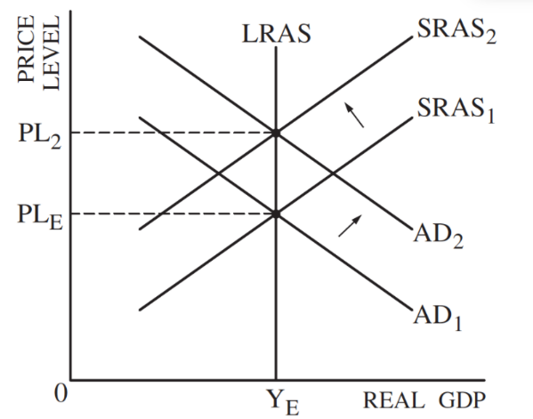
1
B One point is earned for showing a rightward shift of the AD curve on the graph in part (a).
One point is earned for stating that the unemployment rate would fall and explaining that this is because real output increases.
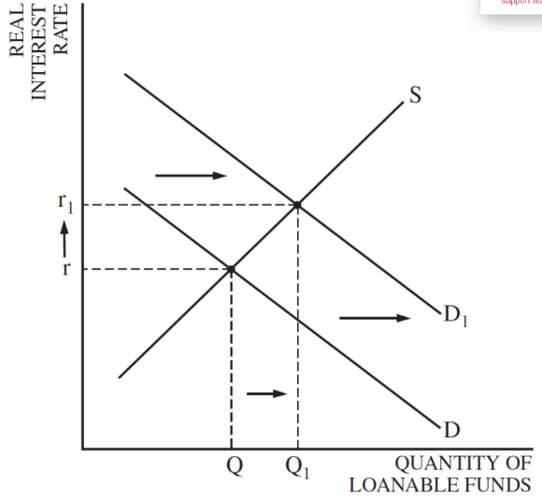
C One point is earned for stating that the short-run aggregate supply curve will shift to the left and showing PL2 correctly on the graph in part (a).
One point is earned for explaining that the actual price level is higher than was expected or that wages and commodity prices adjust to the higher price level, causing the SRAS curve to shift to the left.
D
E One point is earned for stating that investment spending will decrease.
One point is earned for explaining that the decrease in investment slows down capital formation, leading to a reduction in the economic growth rate.
2
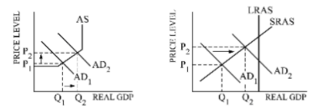
A

B
1 point for interest rates up as government borrows more money in the market for loanable funds or the demand for money increases with a higher GDP.
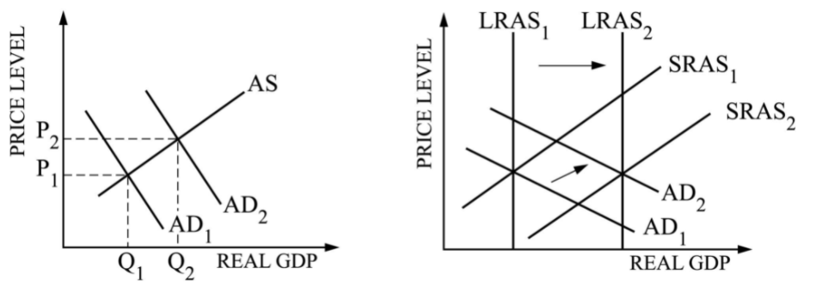
(It is acceptable, of course, to give one point to the student who speaks to the possible ambiguity of the situation given that nominal rates increase and the price level increases.)
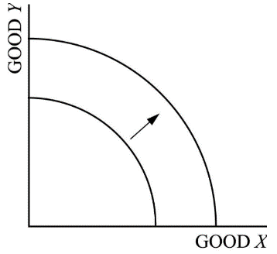
1 point for investment falls — an interest-sensitive expenditure (a point for a correct link of interest change in b (i) to change in investment)
C
D

